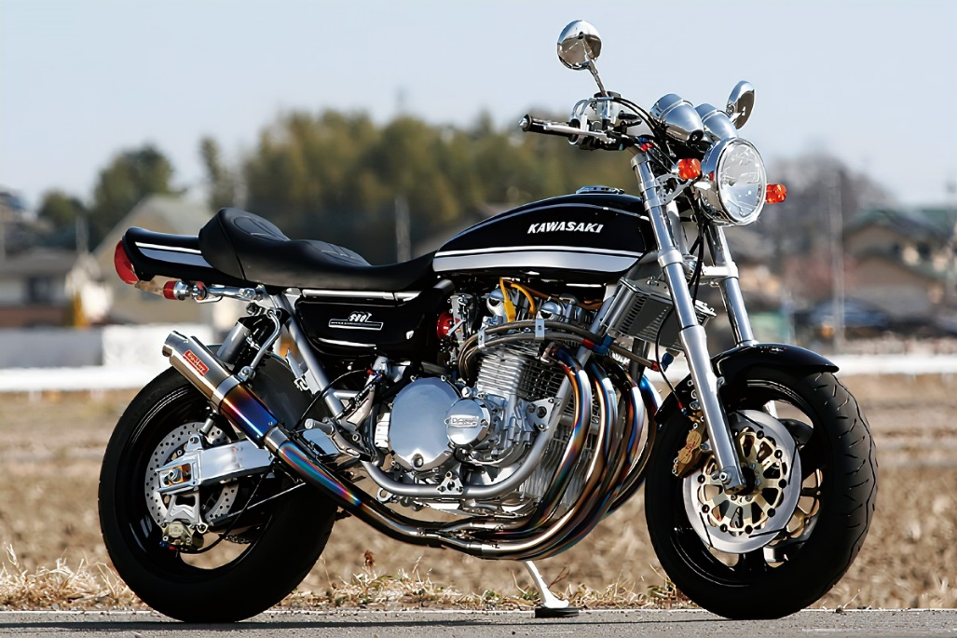

For sale. 2001 Kawasaki café racer. 14,000 miles. Recent new tires and tune up.

Asking $11,000

Call Leo at 928-8x2-63x2 or email LeoGman87@gmail.com

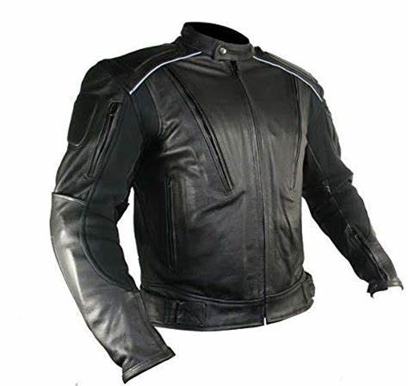

Men’s leather jacket for sale.

Worn one season. Size L

$50

Call Tim at 928-8x2-63x2 or email Timster22@gmail.com